**BASIC LANG CHAIN APP STRUCTUE**

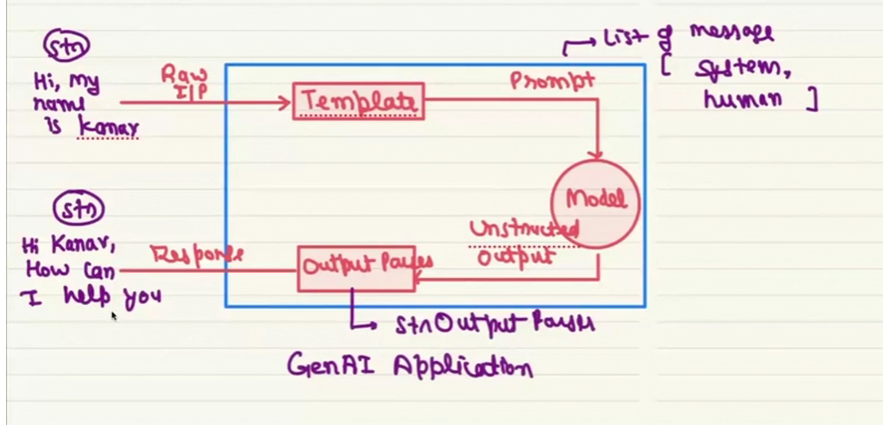

**PRETY PRINT**

Iterates over the model message and prints the response I pretty way.

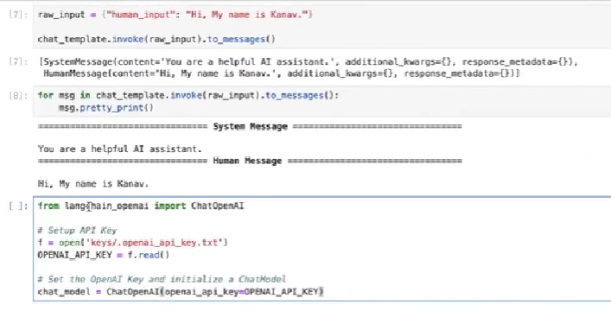

**AUGMENTATION**

Means enhancing the existing capability,

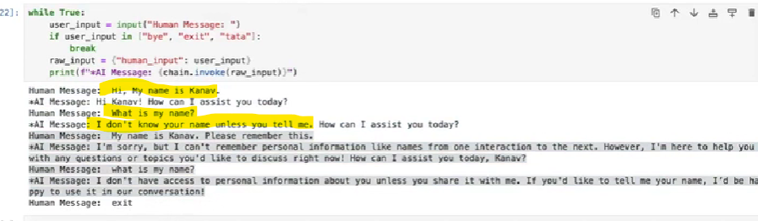

Model’s response is not linked with the previous one, so it doesn’t remember the name of the user, to over come this issue we do augmentation. In the enchantment we will attach memory to the model to memorize the past conversation like the below picture.

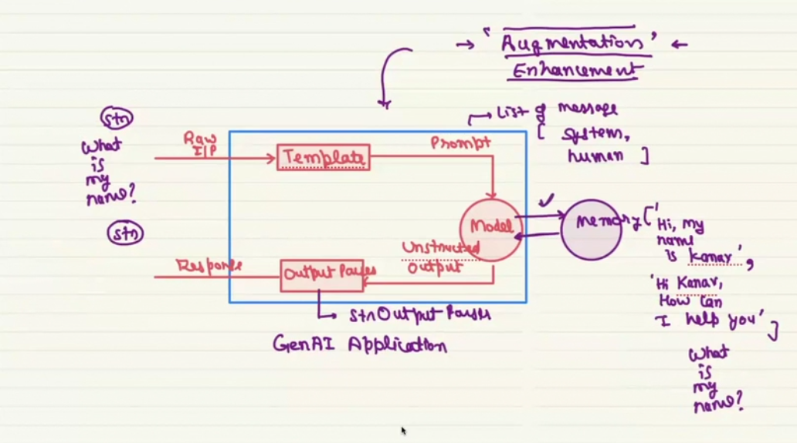

All the chats are memorized in list format on model side will helps model to relate the current conversation with past. One of the data augmentation techniques for this problem is RAG.

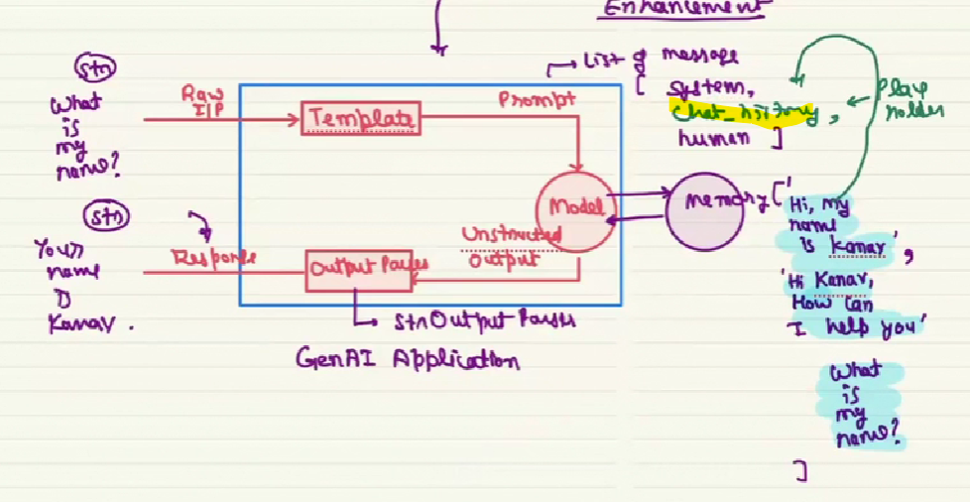

**EXAMPLE OF DUMMY IMPLEMENTATION OF CHAT HISTORY**

By adding two more prompts on chat template prompt with the name of the user model will memorized user’s name but this is not the correct way, because model is now capable to memorize only the name.

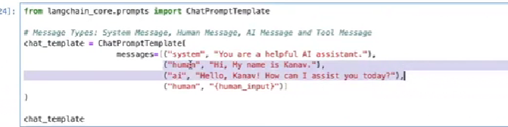

**THRE AUGMENTATION TECHNIQUES**

There are 3 techniques which needs to be implemented on model side to memorize and reterive the chat is

1. Memory augmentation
2. Retrieval augmentation
3. Tool